Lesson 02 – Inputs, Variables, and Math Assignments

All coding assignments will be name Lab (Lesson Number) _ (Problem Number).java unless otherwise stated. EX: Lab01_01.java

Add a comment in the first couple line of your code with your name and the date.

All written assignments will be name Lab (Lesson Number) _ Questions.txt or Lab (Lesson Number) _ Questions.docx. The question will go inside.

In the header of the doc or first few line (txt), put your name and the date.

**Comment all code in meaningful ways that would help other, not knowing about coding, understand what is going on.**

Coding Problems

1. Create a simple calculator what will add the two number that the user inputs and display the result.
2. Create a simple calculator what will subtract the two number that the user inputs and display the result.
3. Create a simple calculator what will multiply the two number that the user inputs and display the result.
4. Create a simple calculator what will divide the two number that the user inputs and display the result. A division error should have occurred. In the doc, explained how you fixed this problem.
   1. The division error occurred when trying to divide numbers that would result in a decimal. For example, dividing 9 and 2 would result in the answer, 4, which is incorrect. I fixed the issue by changing all the primitive data types from “int” to “double.” The answers are now accurate and do not produce incorrected numbers.
5. Create a BMI Calculator that will ask the user for their name, weight and height and output their name and BMI
6. Create a calculator that will calculate the volume of a cylinder.
7. Create a calculator that will calculate the surface area of a cylinder.

Debugging problems

1. 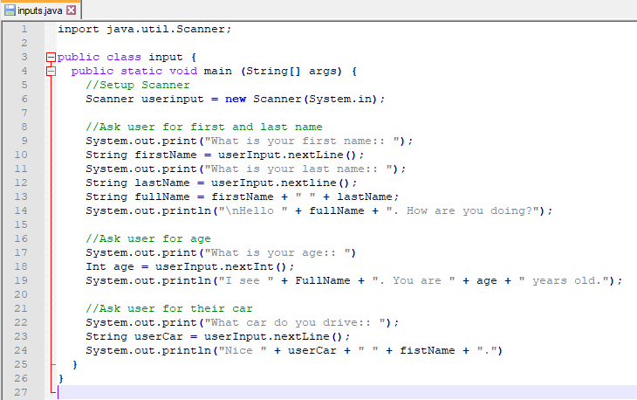
   1. There are 9 errors find all of them
      1. Change “input” to “inputs” on line 3 to match up with the title
      2. Capitalize “input” on line 6
      3. Change “inport” to “import” on line 1
      4. Capitalize “line” on line 12
      5. Line 17 missing “;” at end of statement
      6. Line 18 needs to have the “i” in “Int” lowercase
      7. Line 19 should have the “f” in “FullName” lowercase
      8. Line 24 missing “;” at end of statement
      9. Line 24 has first misspelled to “fist”
2. On my github there is a inputs.java class that when run, skips over asking the user for the car. Fix this error in the code and turn it in. Also write what the error is, why it occurs, and how you fixed it.
   1. The error seems to be that you cannot have a section of string commands, then int commands, then string commands again. When using these commands, all string commands must be declared first before switching to int commands. Or else, the last string command will be ignored. I fixed it by moving the car commands above the age commands which solved the problem.